CTA Module 8 Portfolio Project
Anthony Colasante
CSC450
Dr Bindu George
This Java program uses two threads that do not run at the same time because of the join() method. Similarly to c++, the join() method forces the program to wait for the first thread to finish before starting the second thread. Similarly to the last assignment written in C++, this means the program behaves more sequentially than concurrently. While threads can improve performance, using threads in this instance is overkill and can actually reduce performance. It can reduce performance as it forces the system to use extra resources to create and manage the threads.
Another performance issue with threads is scheduling and that an operating system must manage when threads are running and when to switch between them. In larger applications, many concurrent threads and context switches can slow the program down.
In terms of vulnerabilities, since the strings and variables are all hardcoded and not user inputted values, we do not have to worry about string related attacks. If we were to accept user input data, we would need to sanitize it. Being that Java has automatic memory management, it is a bit safer than lower-level languages, but inputs still need to be validated.
The primary data type used in this program is int and the int variable is stored in i in both loops to count up and down the numbers. This is safe because values are small and controlled directly in the program. Larger integer values can because a security issue if the input is not validated. These issues could be overflow, underflow and negative values could also create additional logic errors.
When it comes to Java vs C++, both languages support concurrency, but they implement threading, memory and security differently. In both versions, we threads are created that count up and down. One difference is how memory is managed. Being that C++ provides low-level access to memory, it allows developers to directly manage resources and compiles directly to native machine code. Those two combined generally mean C++ has faster execution times and lower memory overhead than Java.
In this specific counter application, the C++ runs faster as it does not have to run on the JVM (Java Virtual Machine), it runs directly on the hardware. Even though C++ runs faster, Java includes built-in concurrency support and libraries that simplify writing the programs. C++ has standard libraries now, but the synchronization is typically done manually using mutexs and locks to avoid race conditions and deadlocks.
Another point to make in terms of performance is that Java automatically manages memory using garbage collection reducing memory leads and pointer errors. This improves reliability, it can temporarily pause execution while memory cleanups occurs. While this can slow the program down, it makes Java generally less vulnerable to memory corruption issues and exploits. C++ on the other hand is considered memory-unsafe because it allows unrestricted pointer arithmetic and direct memory manipulation. C++ developers are responsible for validating memory access and ensuring that resources are released properly. If concurrency is not managed carefully, multiple threads accessing shared memory can cause data corruption or unexpected behavior. Java still faces risks such as race conditions and deadlocks, but it provides strong built-in safeguards and higher level abstractions for managing threads safely.
String handling also demonstrates security differences between the two languages. In the Java program, strings are immutable, meaning values cannot be changed after created. This immutability improves the thread safety and prevents accidental modification of data. Java also has an automatic bounds checking which reduces the risk of string related memory corruption issues. In contracts, C++ strings can be manipulated more directly, especially with access to low-level character arrays instead of the standard std:string. If strings are handled improperly, it may result in buffer overflows or memory corruption, if input is not validated. While the C++ implementation only used constant string literals, which means it is safe, larger applications with external input would face higher risks.
The handling of data types also affects security. Both versions use integer variables to perform counting operations. The int data type is safe in this example because the values are small and controlled by the program. However, in applications that do not sanitize user input are more susceptible to integer overflows and underflows. In Java, when we declare an int variable, it is an int32 so we know the fixed size. In C++, the int size can vary based on the operating system, cpu architecture and compiler, not guaranteeing that it's going to be 32 bits. This means that if it makes it a 16 bit integer, it can store a smaller max value making the overflow possibility higher. Java includes runtime checks and a managed environment that reduces these risks.
Overall, the C++ implementation offers better raw performance because it compiles directly to native machine code and avoid the overhead of the JVM. The downside is that it is not running in a VM, closer to the hardware and doesnot have garbage collection. The makes C++ well suited for operating systems, embedded systems, game engined and performance critical applications. With the increased control that C++ has, it also has a greater security risk and is more complex to write. Java sacrifices some performance for improved safety, portability and easier concurrency management. Since Java applications run within the JVM, they have automatic memory management, runtime verification and stronger thread abstractions. This makes Java generally considered less vulnerable to security threats. This is why Java is often preferred in enterprise systems, financial applications and environments where safety and security is more important than speed.
In conclusion, both Java and C++ support concurrency effectively, but they prioritize different goals. C++ emphasizes performance and system-level control, while Java focus on safety and ease of use. The C++ version of the counter application may execute faster and use fewer resources, but it requires more careful memory and thread management. The Java implementation, although slightly less efficient, provides string protection against memory related issues and simplifies writing the concurrent programs. In my personal opinion, C++ is a more difficult syntax to learn, but better to write. I am biased as I have never been a fan of Java and have always been interested in the C based languages!
Screenshots
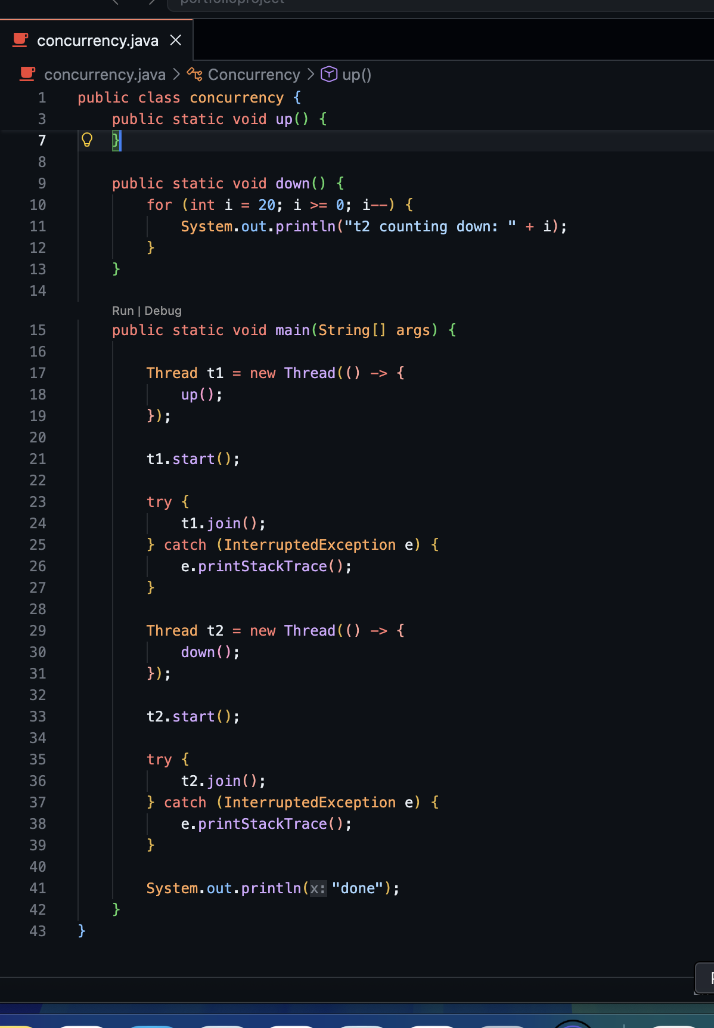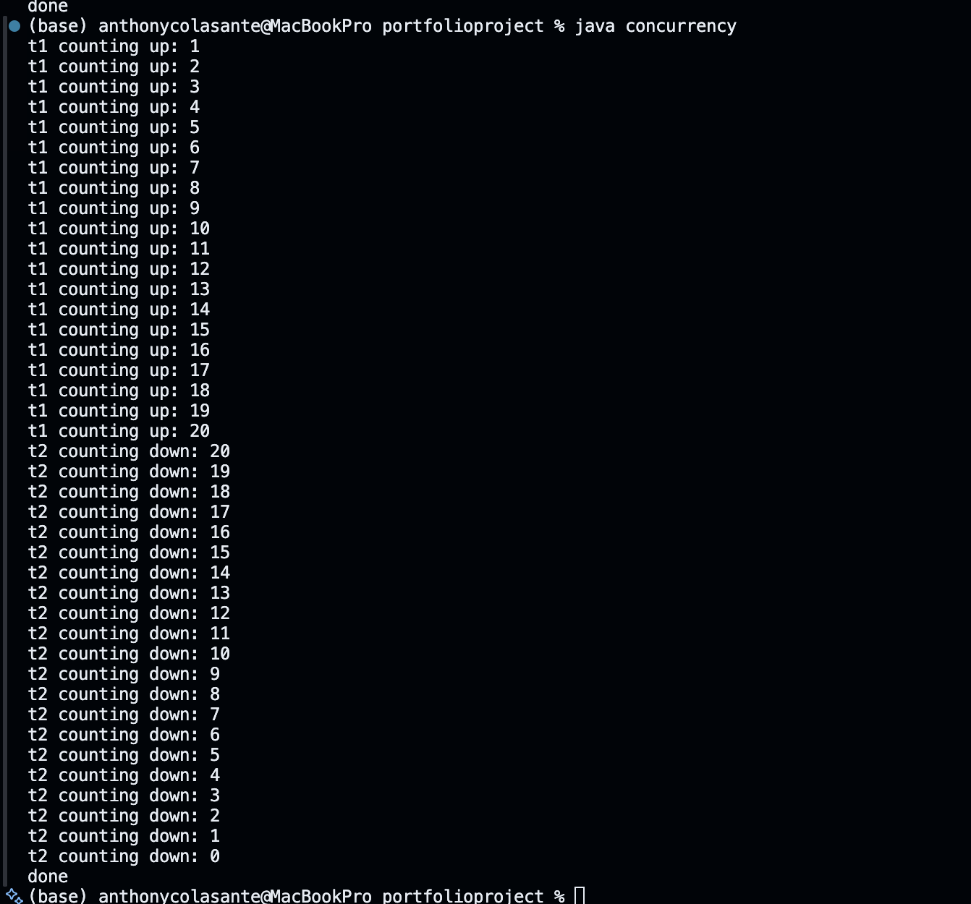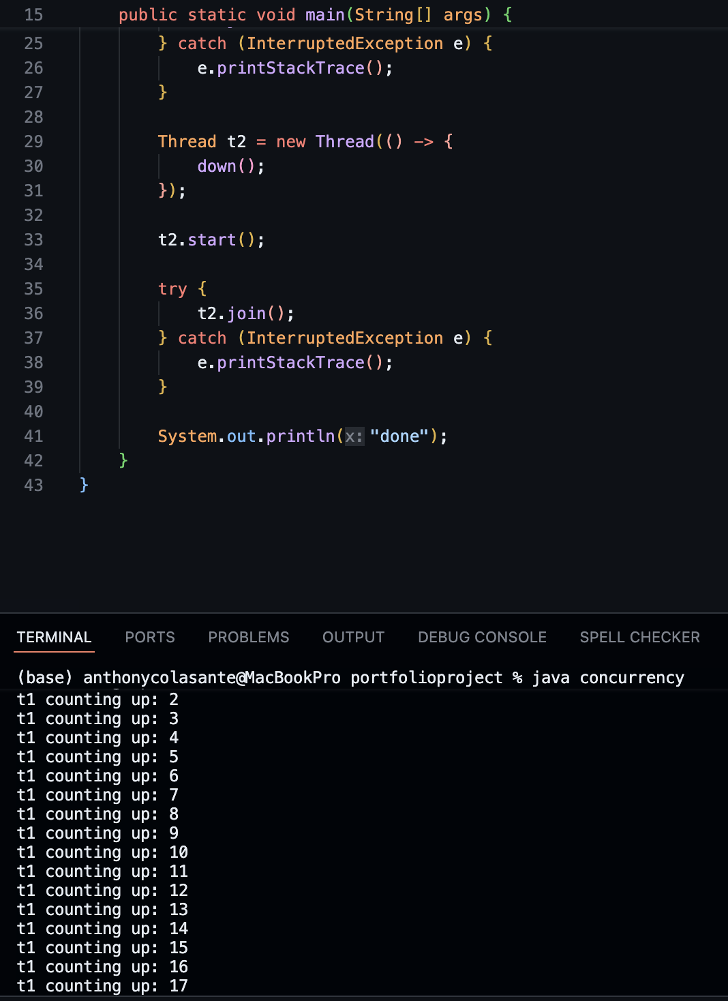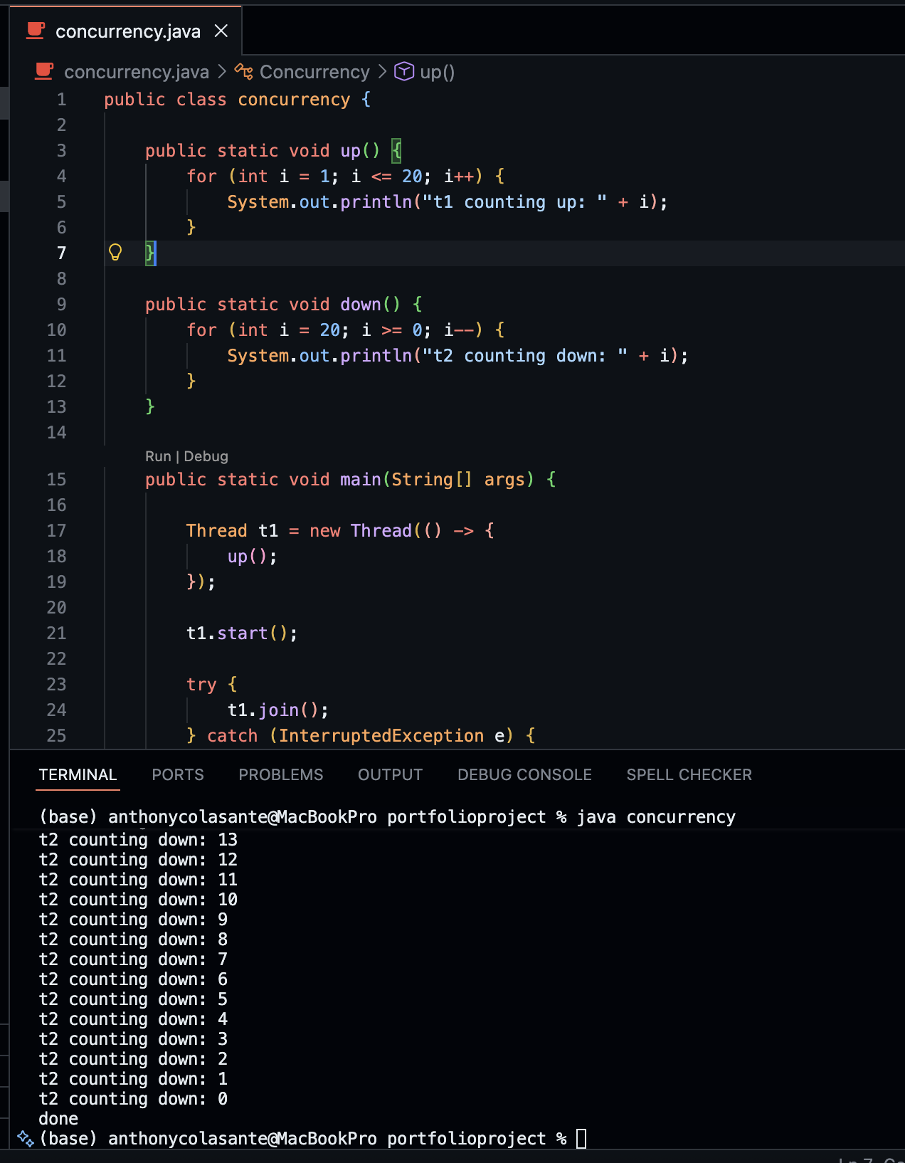
Code:
public class concurrency {

public static void up() {
for (int i = 1; i <= 20; i++) {
System.out.println("t1 counting up: " + i);
}
}

public static void down() {
for (int i = 20; i >= 0; i--) {
System.out.println("t2 counting down: " + i);
}
}

public static void main(String[] args) {

Thread t1 = new Thread(() -> {
up();
});

t1.start();

try {
t1.join();
} catch (InterruptedException e) {
e.printStackTrace();
}

Thread t2 = new Thread(() -> {
down();
});

t2.start();

try {
t2.join();
} catch (InterruptedException e) {
e.printStackTrace();
}

System.out.println("done");
}
}

Github: https://github.com/cocacolasante/csc450portfolioprojectmodule8

